Database Programming with PL/SQL

2-6: Nested Blocks and Variable Scope

Practice Activities

Vocabulary

Identify the vocabulary word for each definition below.

|  |  |
| --- | --- |
| Block label | A name given to a block of code which allows access to the  variables that have scope, but are not visible. |
|  | Consists of all the blocks in which the variable is either local (the  declaring block) or global (nested blocks within the declaring block) |
|  | The portion of the program where the variable can be accessed  without using a qualifier. |

Try It / Solve It

1. Evaluate the PL/SQL block below and determine the value of each of the following variables

according to the rules of scoping.

\

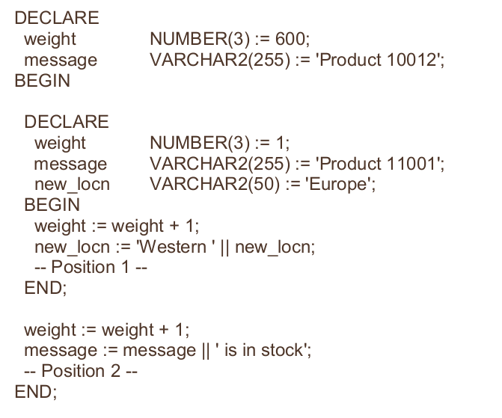A. The value of weight at position 1 is: 2

B. The value of new_locn at position 1 is: Western Europe

C. The value of weight at position 2 is: 601

D. The value of message at position 2 is: Product 10002 is in stock

E. The value of new_locn at position 2 is: nu este

2. Enter and run the following PL/SQL block, which contains a nested block. Look at the output and

answer the questions.

**DECLARE**

**v_employee_id employees.employee_id%TYPE;**

**v_job employees.job_id%TYPE;**

**BEGIN**

**SELECT employee_id, job_id INTO v_employee_id, v_job**

**FROM employees**

**WHERE employee_id = 100;**

**DECLARE**

**v_employee_id employees.employee_id%TYPE;**

**v_job employees.job_id%TYPE;**

**BEGIN**

**SELECT employee_id, job_id INTO v_employee_id, v_job**

**FROM employees**

**WHERE employee_id = 103;**

**DBMS_OUTPUT.PUT_LINE(v_employee_id || ' is a(n) ' || v_job);**

**END;**

**DBMS_OUTPUT.PUT_LINE(v_employee_id || ' is a(n) ' || v_job);**

**END;**

A. Why does the inner block display the job_id of employee 103, not employee 100? pentru ca asta

B. Why does the outer block display the job_id of employee 100, not employee 103? pentru ca asta

C. Modify the code to display the details of employee 100 in the inner block. Use block labels.

<<outer>>

DECLARE

v_employee_id employees.employee_id%TYPE;

v_job employees.job_id%TYPE;

BEGIN

SELECT employee_id, job_id INTO v_employee_id, v_job

FROM employees

WHERE employee_id = 100;

DECLARE

v_employee_id employees.employee_id%TYPE;

v_job employees.job_id%TYPE;

BEGIN

SELECT employee_id, job_id INTO v_employee_id, v_job

FROM employees

WHERE employee_id = 103;

DBMS_OUTPUT.PUT_LINE(outer.v_employee_id || ' is a(n) ' || outer.v_job);

END;

DBMS_OUTPUT.PUT_LINE(v_employee_id || ' is a(n) ' || v_job);

END;